Timer Demo

# Overview

This demonstration uses a timer to measure the period of an input signal from a cup anemometer and then displays the calculated wind speed on the LCD.

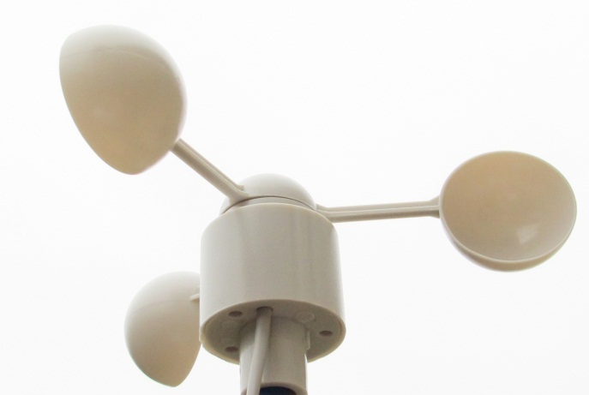

Figure 1. Example cup anemometer.

# Wind Speed Calculation

The frequency f of the anemometer’s signal depends on the wind speed V, the distance r from the anemometer axle to the center of the cup, and the number of pulses per rotations N:

$$f=\frac{VN}{2πr}$$

The period T is the inverse of the frequency:

$$T=\frac{2πr}{VN}$$

The program measures the low portion of the signal period T, which depends on the duty cycle of the signal d:

$$T_{Low}=\frac{\left(1-d\right)2πr}{VN}$$

Solving for wind velocity V as a function of time:

$$V=\frac{\left(1-d\right)2πr}{T_{Low}N}$$

Solving for wind velocity V as a function of count value C given count frequency fc:

# Schematic

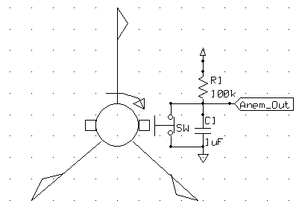

Figure 2. Schematic of anemometer circuit.

# Connections

|  |  |  |  |
| --- | --- | --- | --- |
| **Description** | **MCU Pin** | **Signal Name** | **Direction** |
| Anem_Out | 3 | TIO3 | Input |
| 3.3 V Power | 15 or 16 | 3V3 | Common |
| Ground | 13 or 14 | GND | Common |

# Comments and Suggestions

* Be sure to debounce the switch of the anemometer using a large capacitor (e.g. 1 uF). Otherwise the anemometer switch contact may bounce, leading to noisy readings (unrealistically high wind speeds).
* The RDK uses MCU pin 3 to enable the audio output amplifier. Rotating the anemometer at low speeds will toggle this signal, causing the speaker to click.